

**ATM USING C LANGUAGE**

**Submitted By:**

SHASHIKANT SG21CSE131

VAMSHI KRISHNA SG21CSE164

VENKATESH PRASAD R SG21CSE169

SHIVAPRASAD LATERAL

**Guided By:**

Prof. REVATI SUGOOR

**Table of contents:**

|  |  |  |
| --- | --- | --- |
| **SL.NO** | **PARTICULARS** | **PAGE NO.** |

1. INTRODUCTION
2. LITERATURE SURVEY
3. WORKING OF ATM
4. FLOWCHART
5. PROGRAMMING

REFERENCES

|  |
| --- |
|  |

**ABSTRACT**

This application allows the customers to collect cash know the balance know the account status, credited or debited status. It allows authorized users to access the system by insert a valid pin number. It also enables to make transaction on the current account. Reducing cost to bank because does not require staff work that many to show customers. Even many advantages to users because every matter can carried out anywhere.

**CHAPTER 1:**

* **INRODUCTION:**

An **automated teller machine** (**ATM**) is an electronic telecommunications device that enables customers of financial institutions to perform financial transactions, such as cash withdrawals, deposits, funds transfers, balance inquiries or account information inquiries, at any time and without the need for direct interaction with bank staff.

Using an ATM, customers can access their bank deposit or credit accounts in order to make a variety of financial transactions, most notably cash withdrawals and balance checking, as well as transferring credit to and from mobile phones. ATMs can also be used to withdraw cash in a foreign country. If the currency being withdrawn from the ATM is different from that in which the bank account is denominated, the money will be converted at the financial institution's exchange rate. Customers are typically identified by inserting a plastic ATM card (or some other acceptable payment card) into the ATM, with authentication being by the customer entering a personal identification number (PIN), which must match the PIN stored in the chip on the card (if the card is so equipped), or in the issuing financial institution's database.

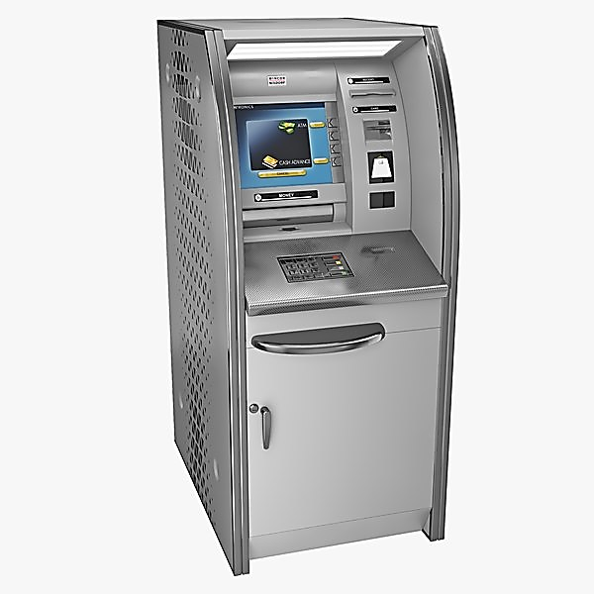

**CHAPTER-2**

* **LITERATURE SURVEY**

The project is based upon using C language. In this application an user uses C language to identify the usage of ATM and what code is used in an ATM machine, the project shows the following details when the user accesses his/her account by applying the PIN which he or she has and the code which will be confidential to only user. After updating the PIN the user can credit/debit the money, know the account details.

**CHAPTER-3**

* **Working of ATM:**

Internet service providers play a crucial role in the efficient working of ATMs. It stabilizes the connection between the host processors and the atm. Once a translation is initiated, information is added by the cardholder. These are passed onto the host processors, where authorization is provided upon checking the details. Once the details are verified, host processors send an approval code for the transaction.  
  
 ATM cards are strongly secured by encryption through strong software such as Triple data encryption slandered. The automated teller machine has a very simple working principle. A simple terminal with two inputs and four output devices controls digital transaction services.  
  
 All parts of the devices are associated with an interfaced processor. If the cardholder wishes to withdraw cash, the processor redeems cash from the cardholder's account. Once the fund is transferred to the host processor's account, an approval code is dispatched, and the required cash is dispensed.

* **A step-by-step algorithm for operating the ATM is mentioned down below.**
* Visit the ATM nearest to you and place your ATM card in the cardholder.
* Set your preferred language showcased on the screen with the help of buttons on the side of the screen
* Select the transaction you wish to perform
* Choose the account type for performing the transaction.
* Now enter your PIN through the keypad and the amount you wish to withdraw.
* Wait for a few seconds until the transaction is completed, and then you can collect your amount from the cash dispenser.
* You can collect the receipt you want and move on to any other transaction you wish to perform, or press the exit button and leave.

ATM design is a combination of hardware and software. Hardware designs include deposition and withdrawal of cash, credit card payments and entering and obtaining account information. The software controls ATM transactions**.**

**ATM USING C:**

* **FLOWCHART:**

C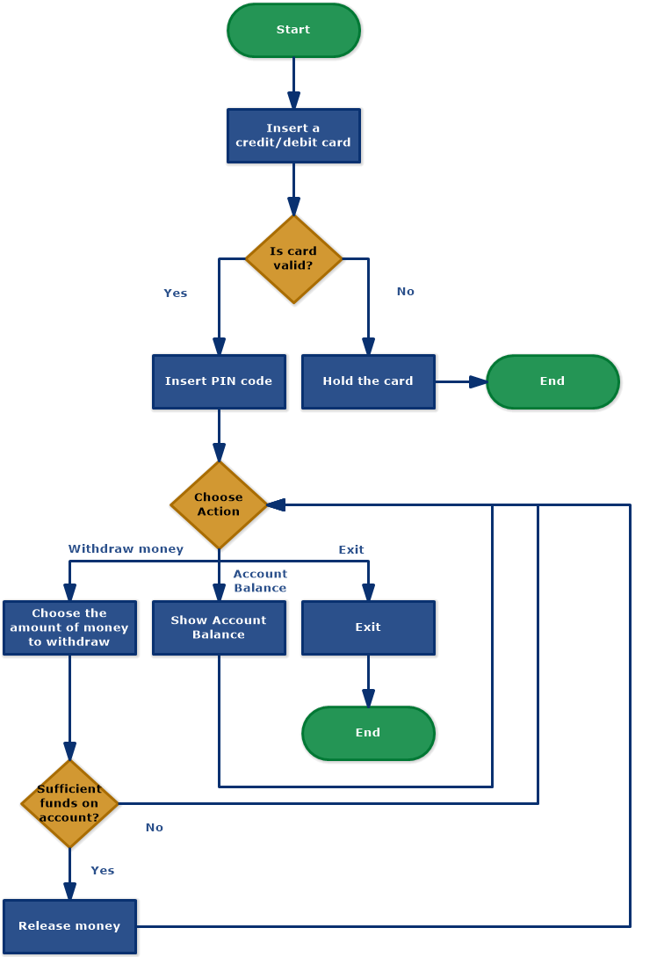

* The process for **cash withdrawal from ATM** is described using the following flowchart nodes:
* Start
* Insert a credit/debit card
* Is card valid?
* Insert PIN code
* Hold the card
* Choose Action
  + Withdraw money
  + Account balance
  + Exit
* Choose the amount of money to withdraw
* Show account balance
* Sufficient funds on the account?
* Release money
* End

* **Code used:**

/*

*C Program to Display the ATM Transaction

*/

#include <stdio.h>

unsigned long amount=1000, deposit, withdraw;

int choice, pin, k;

char transaction ='y';

void main()

{

while (pin != 1520)

{

printf("ENTER YOUR SECRET PIN NUMBER:");

scanf("%d", &pin);

if (pin != 1520)

printf("PLEASE ENTER VALID PASSWORD\n");

}

do

{

printf("********Welcome to ATM Service**************\n");

printf("1. Check Balance\n");

printf("2. Withdraw Cash\n");

printf("3. Deposit Cash\n");

printf("4. Quit\n");

printf("******************?**************************?*\n\n");

printf("Enter your choice: ");

scanf("%d", &choice);

switch (choice)

{

case 1:

printf("\n YOUR BALANCE IN Rs : %lu ", amount);

break;

case 2:

printf("\n ENTER THE AMOUNT TO WITHDRAW: ");

scanf("%lu", &withdraw);

if (withdraw % 100 != 0)

{

printf("\n PLEASE ENTER THE AMOUNT IN MULTIPLES OF 100");

}

else if (withdraw >(amount - 500))

{

printf("\n INSUFFICENT BALANCE");

}

else

{

amount = amount - withdraw;

printf("\n\n PLEASE COLLECT CASH");

printf("\n YOUR CURRENT BALANCE IS%lu", amount);

}

break;

case 3:

printf("\n ENTER THE AMOUNT TO DEPOSIT");

scanf("%lu", &deposit);

amount = amount + deposit;

printf("YOUR BALANCE IS %lu", amount);

break;

case 4:

printf("\n THANK U USING ATM");

break;

default:

printf("\n INVALID CHOICE");

}

printf("\n\n\n DO U WISH TO HAVE ANOTHER TRANSCATION?(y/n): \n");

fflush(stdin);

scanf("%c", &transaction);

if (transaction == 'n'|| transaction == 'N')

k = 1;

} while (!k);

printf("\n\n THANKS FOR USING OUT ATM SERVICE");

}

* Output:

ENTER YOUR SECRET PIN NUMBER:1520

********Welcome to ATM Service**************

1. Check Balance

2. Withdraw Cash

3. Deposit Cash

4. Quit

******************?**************************?*

Enter your choice: 1

YOUR BALANCE IN Rs : 1000

DO U WISH TO HAVE ANOTHER TRANSCATION?(y/n):

********Welcome to ATM Service**************

1. Check Balance

2. Withdraw Cash

3. Deposit Cash

4. Quit

******************?**************************?*

Enter your choice: 2

ENTER THE AMOUNT TO WITHDRAW: 200

PLEASE COLLECT CASH

YOUR CURRENT BALANCE IS 800

DO U WISH TO HAVE ANOTHER TRANSCATION?(y/n):

********Welcome to ATM Service**************

1. Check Balance

2. Withdraw Cash

3. Deposit Cash

4. Quit

******************?**************************?*

Enter your choice: 3

ENTER THE AMOUNT TO DEPOSIT 5000

YOUR BALANCE IS 5800

DO U WISH TO HAVE ANOTHER TRANSCATION?(y/n):

********Welcome to ATM Service**************

1. Check Balance

2. Withdraw Cash

3. Deposit Cash

4. Quit

******************?**************************?*

Enter your choice: 1

YOUR BALANCE IN Rs : 5800

DO U WISH TO HAVE ANOTHER TRANSCATION?(y/n):

********Welcome to ATM Service**************

1. Check Balance

2. Withdraw Cash

3. Deposit Cash

4. Quit

******************?**************************?*

Enter your choice: 4

THANK U USING ATM

DO U WISH TO HAVE ANOTHER TRANSCATION?(y/n):

********Welcome to ATM Service**************

1. Check Balance

2. Withdraw Cash

3. Deposit Cash

4. Quit

******************?**************************?*

Enter your choice: 4

THANK U USING ATM

DO U WISH TO HAVE ANOTHER TRANSCATION?(y/n):

********Welcome to ATM Service**************

1. Check Balance

2. Withdraw Cash

3. Deposit Cash

4. Quit

******************?**************************?*

Enter your choice: n

THANK U USING ATM

DO U WISH TO HAVE ANOTHER TRANSCATION?(y/n):

THANKS FOR USING OUT ATM SERVICE

* **Major functionalities used in atm machine program in C language**

1. **MAIN MENU SCREEN WINDOW**

When you start the project from any compiler or by double-clicking the executable.exe file, you’ll see the screen shown below is main screen window.  In the image below, which is for the main menu of ATM machine such as check balance, deposit money and withdraw money.

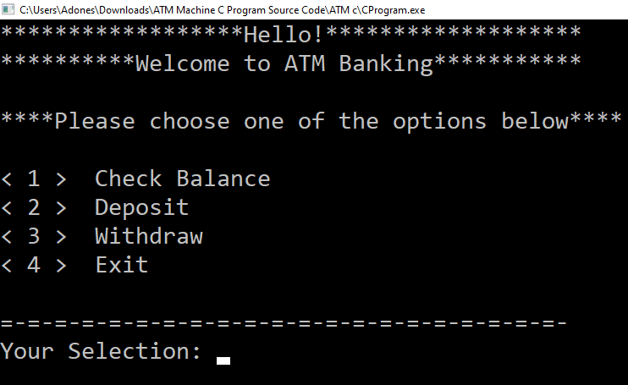

1. **CHECK BALANCE**

In the image below, which is for the check balance screen window.

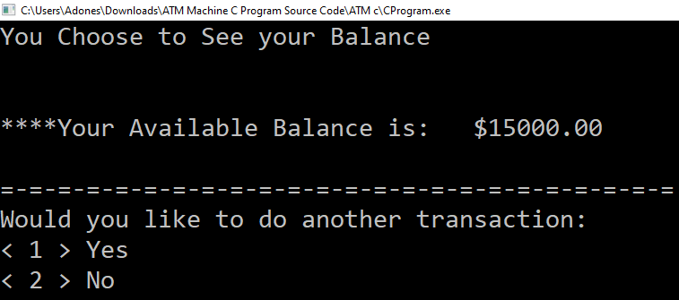

1. **DEPOSIT MONEY**

In the image below, which is for the deposit money screen window.

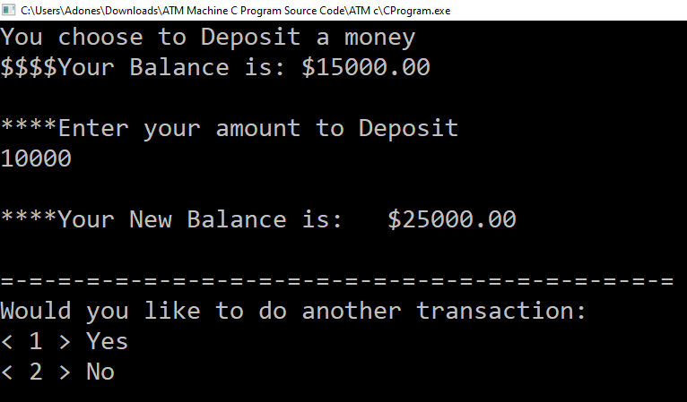

1. **WITHDRAW MONEY**

In the image below, which is for the withdraw money screen window.

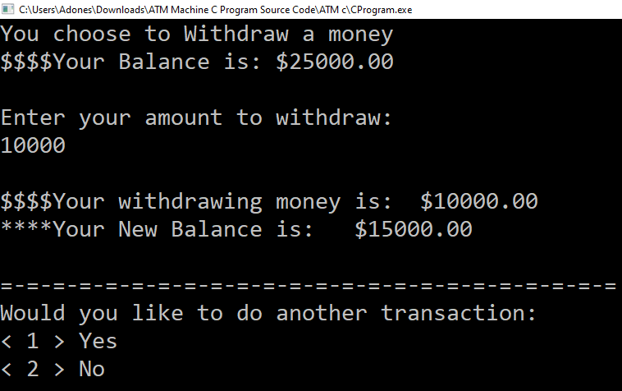

## Conclusion

This C program used for ATM machine is a project created only for the purpose of meeting educational requirements. For a semester project, I developed a ATM Machine C Programing Language.

Its goal is to provide newcomers with a solid foundation in programming small to large projects by providing useful and practical information about C.

**References:**

Code references:

<https://github.com/>

<https://itsourcecode.com/free-projects/c-projects/atm-machine-c-program-with-source-code/>